Eatons Hill Medical Centre
Ferinject Infusion Patient Consent Form

I understand that the administration of FERINJECT comes with the following risks, included but not limited to:
- Anaphylactic reactions, which in rare cases may be potentially fatal
- Paravenous leakage- leakage in FERINJECT at injection site, potentially leading to long lasting skin discolouration. Please refer to images of leakage in page 4
- Skin Irritations and Pain
- Headaches, Light Headedness
- Tachycardia, Hyper/Hypotension
- Nausea, Stomach pain, Constipation, Diarrhoea and Vomiting

Minor reactions to FERINJECT may last up to 48 hours post infusion.
For full list of reactions, please see page 3.

Understanding these risks, I give authority for staff of Eatons Hill Medical Centre to administer all necessary first aid and/or resuscitation measures, including alerting an ambulance and my Emergency Contact, in the unlikely event that an adverse or anaphylactic reaction occurs.
As FERINJECT is not suitable for patients in some conditions, I declare that none of the below listed is applicable:

- Pregnancy in the first trimester
- Dialysis
- Allergy to Ferric Carboxymaltose
- Iron overload/Haemochromatosis
- Under the age of 14 years
- Non-iron deficiency related anaemia
- Suffering from inflamed tissues, ulcers, fever, sepsis
- Uncontrolled hyper/hypothyroidism
- Substance abuse
- Liver disease

The patient, as stated below, has read information provided on this document as well as the
- Managing My Iron Fact Sheet
- Bloodsafe Information Sheet
- EHMC Iron Infusion Information Sheet (including preparation outline)
relating to the administration of FERINJECT.
I understand that the procedure is undertaken entirely at own risk and cost and is requesting medical intervention in the form of an Intravenous Iron Infusion.
I understand that Eatons Hill Medical Centre only provides the service of iron infusion and is not responsible for the investigation on the causes of my iron deficiency and definitive management.
I understand and acknowledge that this procedure involves insertion of an IV cannula and will require me to remain for 30 minutes after the procedure has been completed. Please allow 1.5 hours for this appointment.
I acknowledge that I have had the opportunity to ask questions about the procedure and I am satisfied with the information I have received.

Patient Full Name: ........................................................ DOB: ....................................
Patient Signature: ......................................................... Date: ...................................
Doctor Signature: .......................................................... Date: ...................................
Copy of Blood Test obtained and scanned to patient file

Eatons Hill Medical Centre
Ferinject Infusion Patient Consent Form

Common Side Effects (Occurs in 1-10% of cases):
• Headache
• Flushing
• Nausea
• Low blood phosphate levels
• Injection/Infusion site reactions

Uncommon and Rare Side Effects (Occurs in <1% of cases):

• Hypersensitivity
• Numbness
• Increased heart rate
• Hypotension
• Difficulty breathing
• Taste disturbance
• Vomiting
• Dyspepsia
• Flatulence
• Abdominal pain
• Constipation
• Diarrhoea
• Itchiness
• Hives (urticaria)
• Redness (erythema)
• Rash
• Muscle pain or spasm
• Back, joint or chest pain
• Fever
• Fatigue
• Accumulation of fluid in periphery
• Pain and chills
• Anaphylaxis
• Rigors
• Malaise
Patient signature: ................................................... Date: .............................
Example of images of iron leakage mild to severe

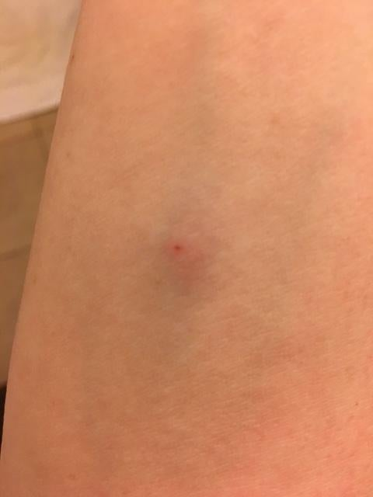

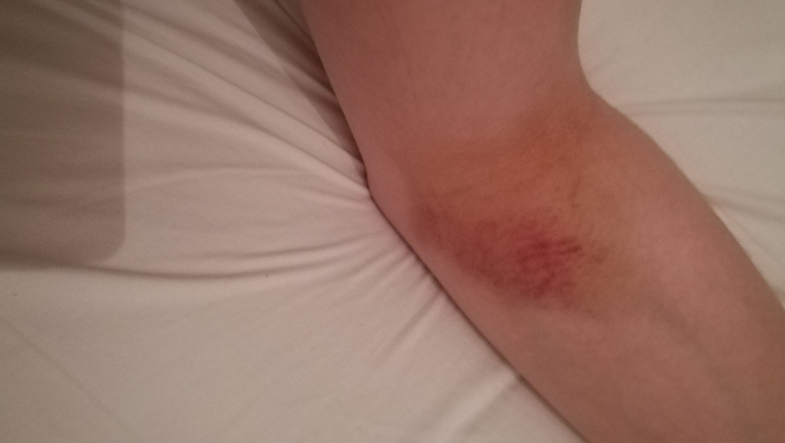

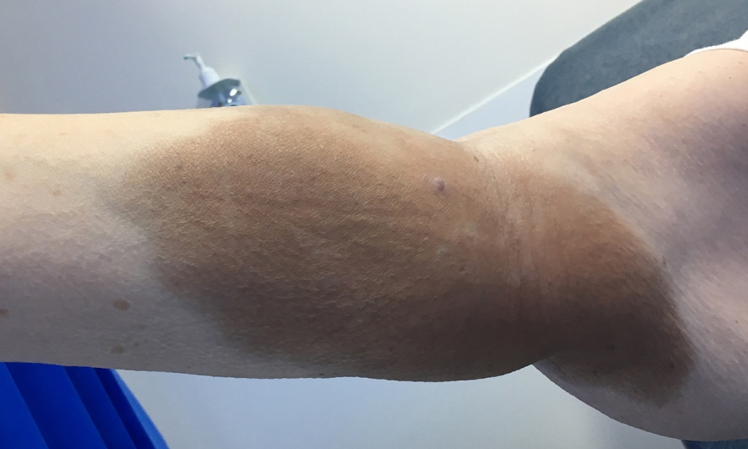

Patient signature: ................................................... Date: ..............................

